**Manual Test Plan - Tank Battle 2.0**

**Week 0:**

**1. StartPage**

Navigating to “/” route. Start Page is displayed where the user can choose to either start a new game or join an existing game with just other player.

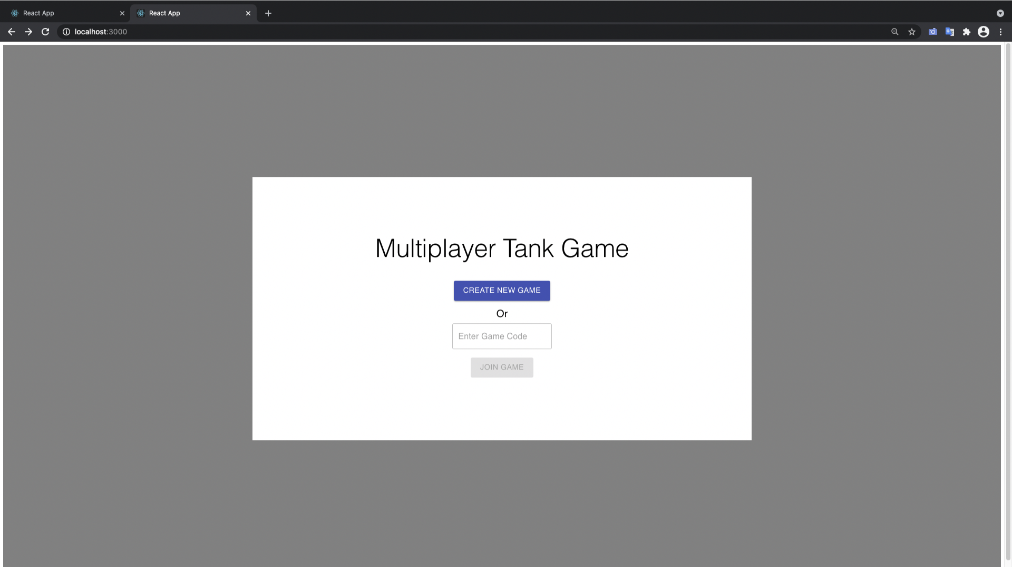

**2. CreateNewGame**

Click on the “Create New Game” button in the Start Page

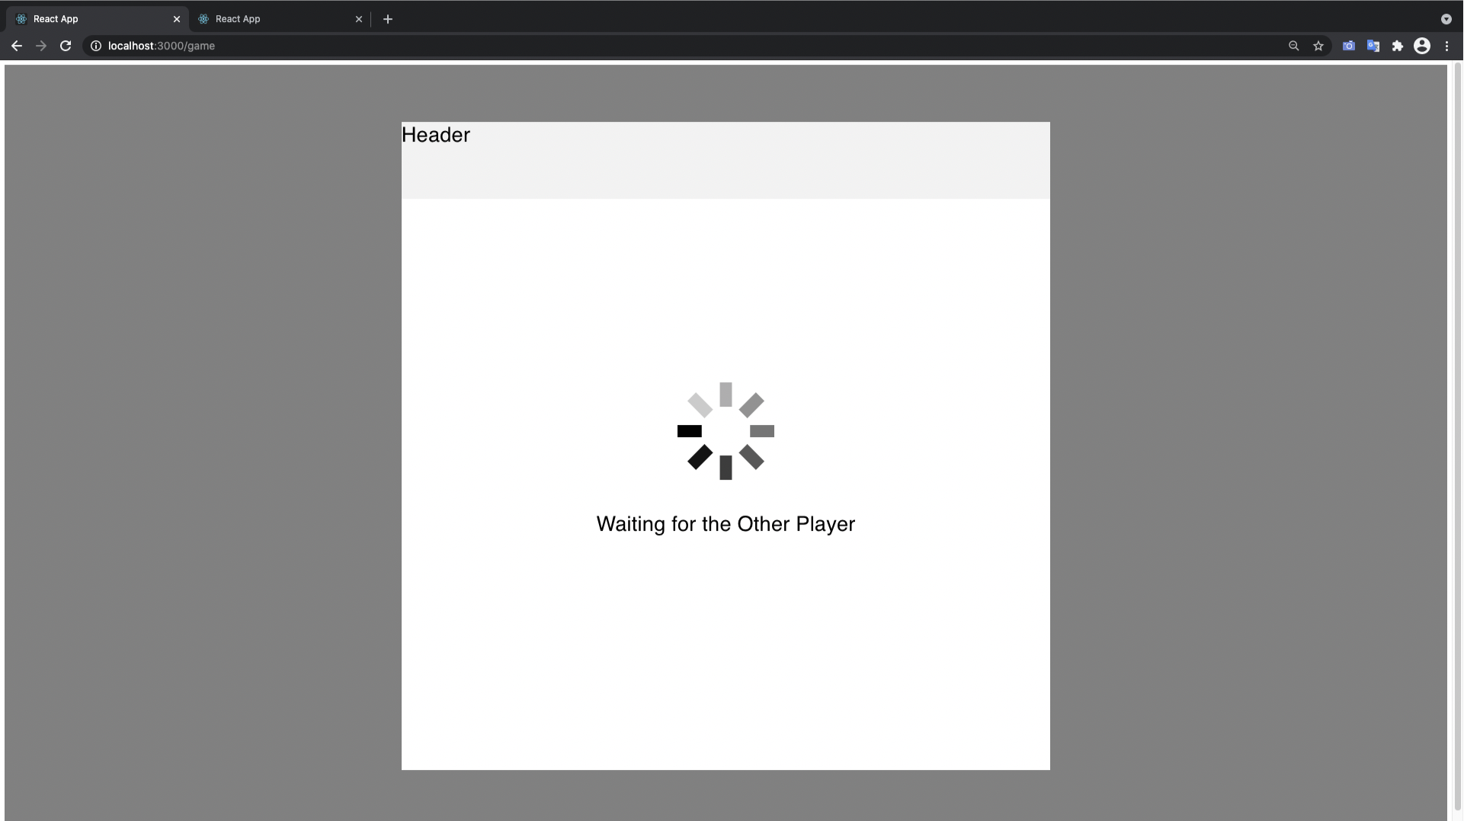

It takes the user to the Game Page and waits for the second player to join

**3. JoinGame**

Click on the “Join Game” button in the Start Page.

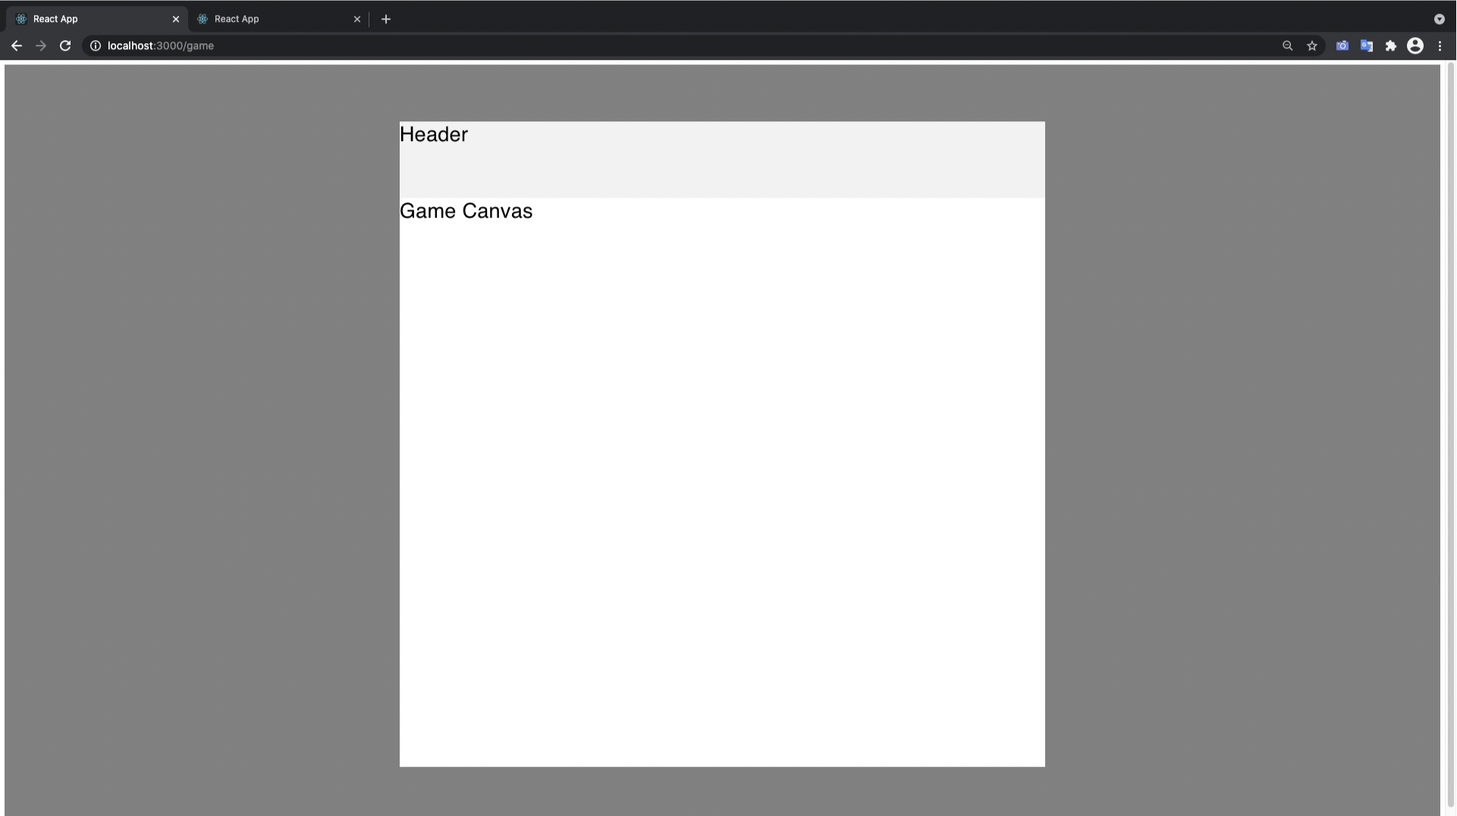

It Takes the User to Game Player and loads the Game canvas

**Week 1:**

**4. Join Game**

Now After both players join the game room. Two tanks one controlled by either player are displayed

**5. Move Player**

Arrow buttons lets the user move the tanks across the screen

**6. Movement is visible in both Players screen**

Moving a player changes the player position on both windows



**7. Player Fires Bullets**

Pressing the space bar lets the user fire bullets towards the enemy

**8. Player Bullets are visible on both Screens**

Fired Bullets are visible on both screens



**Week 2:**

**9. New Game Design**

The game is better styled. Tanks now are represented by tank pictures. The bullets are well designed and there is a timer with stats bar

**10. Bullet hitting a tank**

Hitting a tank shows an explosion animation and reduces health of the tank

**11. Timer**

Timer displays time and it decreases every second

**12. Game Over**

The Game over modal is shown when a player wins.

**Week 3:**

**13. Chat Drawer**

Clicking on the side btn opens the chat drawer and the player can write and send messages

**14. Sending and Displaying Messages**

The Messages are received from the other player and displayed instantly

**15. Audio Chat**

As soon as the game begins players can audio chat

**16. Toggle audio chat buttons**

Clicking the mic and speaker button toggles b/w on and off

